How to Create an Audacity Project File

- Note: By now you should have extracted the sound clips and recorded the voice narrations you need for your project. Follow the steps here to assemble your sound files and create an Audacity project.

- Open the Audacity application on your computer.
Figure 1 Audacity Logo
- Select File->Import->Audio.
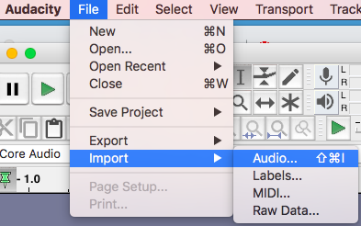
Figure 2 Import Audio File
- Navigate to the .wav file of the clip you want to add to the project. Click “Open”.

- A warning screen will appear. Select “Make a copy of the files before editing (safer)”. Click OK.

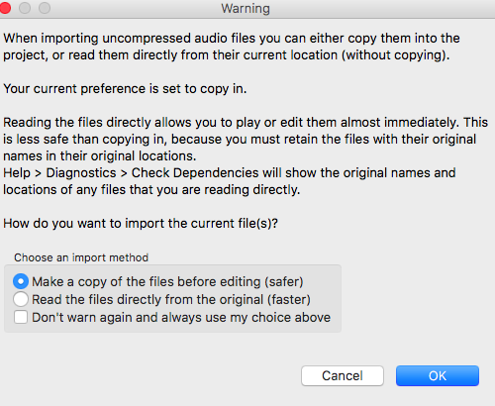
Figure 3 Warning Screen
- The waveform of your extracted clip will be displayed.

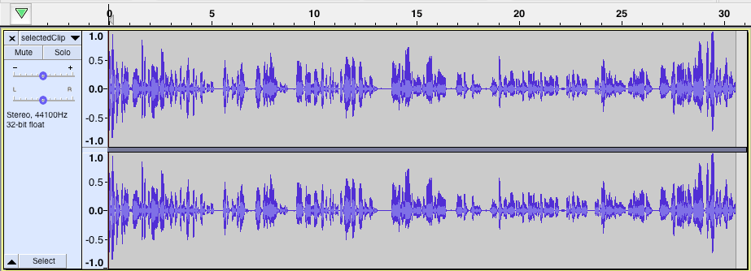
Figure 4 Waveform of Extracted Clip

- Repeat the steps above to import any more files you want to include in the project. Each imported clip will appear in a separate track.

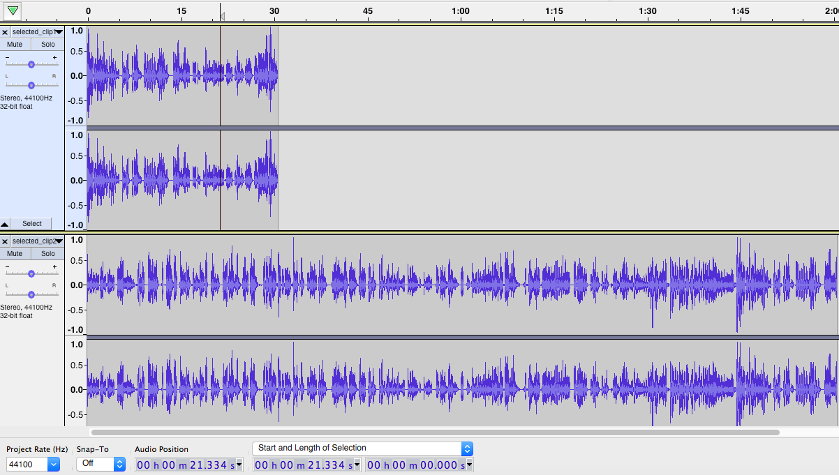
Figure 5 Two Imported Tracks
- You can now arrange the clips in the order you need.
To place the first clip before the second clip, first click the Time Shift Tool.

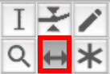
Figure 6 Time Shift Tool
- Drag the second track to the right until the start of the track is aligned with the end of your first track.

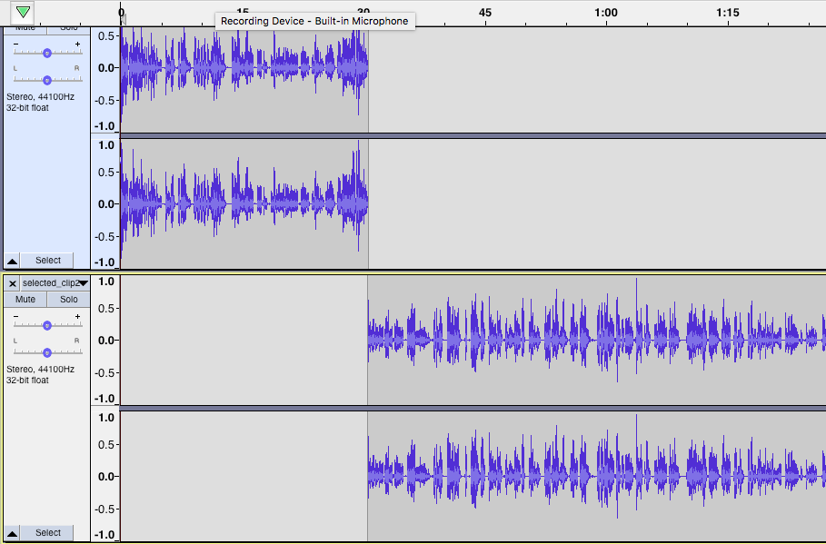
Figure 7 Aligning Tracks
- Note: To insert silence anywhere in your tracks, select the Selection tool
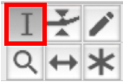
Figure 8 Selection Tool
Place the selection tool at the position you want to insert the silence. From the Audacity menu, select
Generate->Silence.
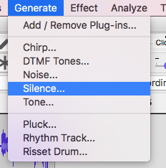
Figure 9 Generate Silence
Enter the duration of the silence. Click OK.

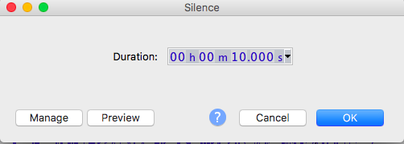
Figure 10 Silence Duration

Silence will appear in the position selected for the duration entered.

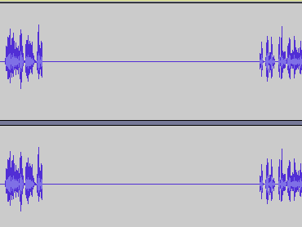
Figure 11 Silence Inserted in the Position Selected

- To save your assembled tracks as an Audacity project, click File->Save Project->Save Lossless Copy of Project…
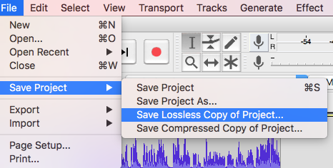
Figure 12 Save Lossless Copy of Project
- A warning sign will appear. Click OK.
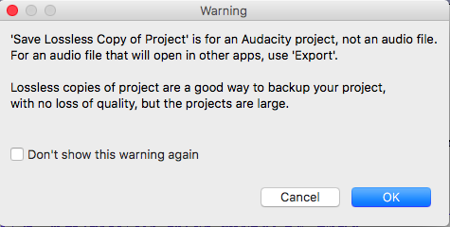
Figure 13 Save Lossless Project Warning
- Enter the name of the project and select the location to save the project file. Click Save to save the project file.
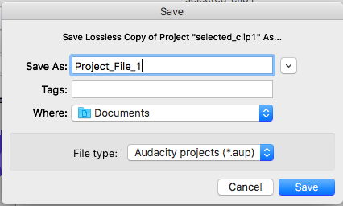
Figure 14 Save Project File

