How to Export the Audacity Project to a Single .wav File

- Open the Audacity application on your computer.
Figure 1 Audacity Logo
- Select File->Open.
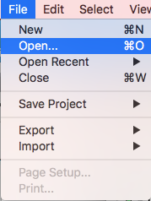
Figure 2 Open Project
Navigate to your Audacity project and click “Open”.
- The project will open in the Audacity project window.

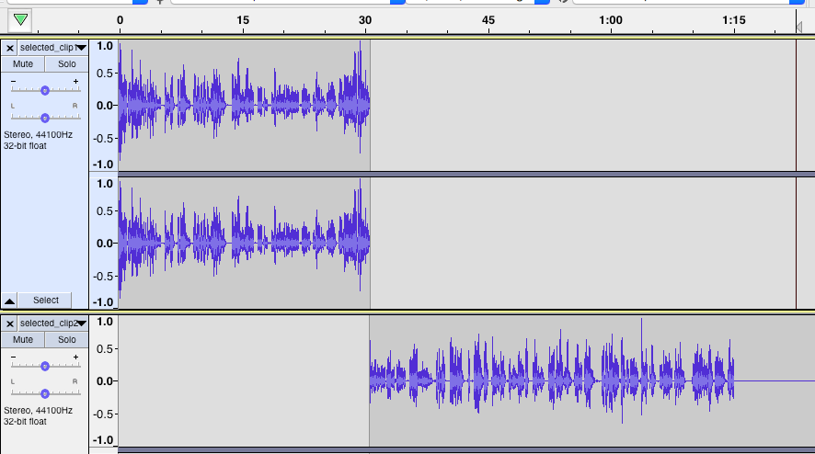
Figure 3 Audacity Project Tracks

- Click File->Export->Export as WAV

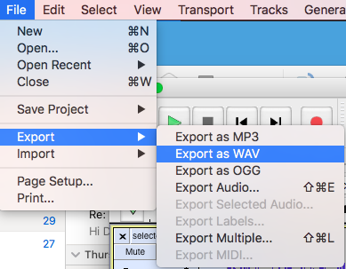
Figure 4 Export as WAV

Enter the file name of the new file and select the location where you want the file to be saved. Click Save.

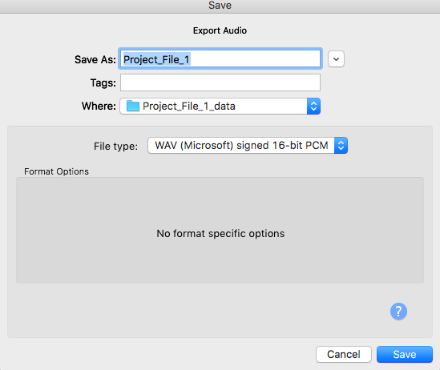
Figure 5 Save WAV file

- You will see a warning that your tracks will be exported as one stereo file. Click OK.

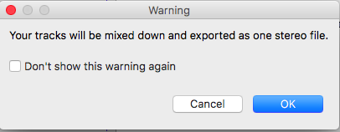
Figure 6 Save as WAV warning
- Edit the meta data for the new file if you wish. Click OK.
Your .wav file should now be saved in the location you selected.

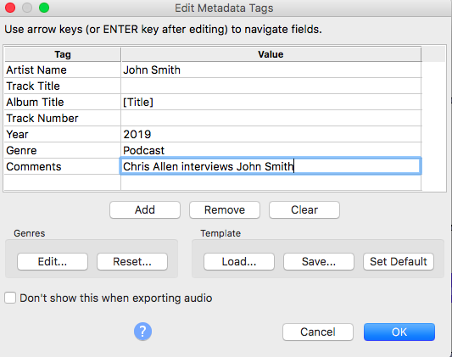
Figure 7 Meta Data

