How to Extract a Clip from your Interview File in Audacity

- Important: It is best to create a folder on your desktop to store your original interview and all other audio and project files.

- Open the Audacity application on your computer.
Figure 1 Audacity Logo
- Select File->Import->Audio.
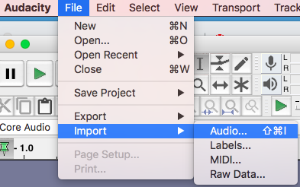
Figure 2 Import Audio File
Navigate to your interview recording file (typically a .mp3 or .wav file) and click “Open”.
- The visual representation of the imported audio track (called a waveform) will be displayed in Audacity project window.

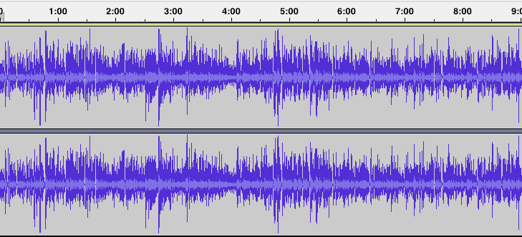
Figure 3 Stereo Waveform
Note: There are two types of audio tracks: mono and stereo. Mono tracks look like one waveform whereas stereo tracks look like two waveforms stacked on top of each other (as shown in figure 3). The two waveforms in stereo tracks, called channels, are for the left and right side of speakers/headphones. To learn more about audio tracks, visit https://manual.audacityteam.org/man/audio_tracks.html

- The ruler above the waveform shows you the length of the audio in minutes and seconds. For example, this is what the clip looks like from zero to five minutes.

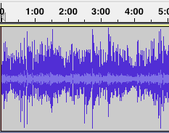
Figure 4 zero to 5 minutes
This is what the clip looks like from zero to one minute after zooming in (time is shown in seconds).
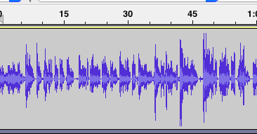
Figure 5 zero to 1 minute
- To extract a clip from your audio track, you first need to zoom in to get into more detail of your clip. Click the zoom button in the edit toolbar to get a closer look at the waveform, and zoom in to get to the right portion that you want to extract from the clip.

Figure 6 Zoom Buttons
- Click the selection tool.
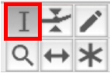
Figure 7 Selection Tool
- Select the portion of the clip you want to extract. In this example, we are going to extract 30 seconds from this clip, from 2:45 to 3:16 1/2.

Use the play button and listen carefully to your selection. Ensure you have a good selection before proceeding to the next step.
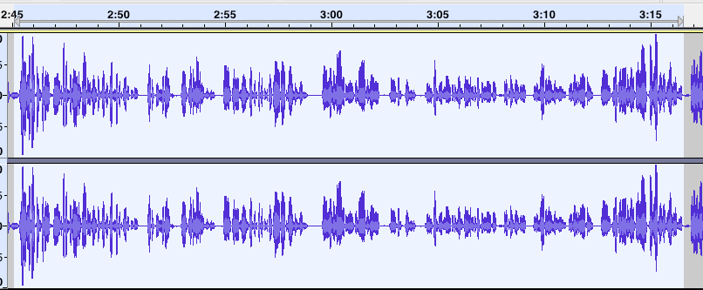
Figure 8 Selected Portion of the Clip
- Click File->Export->Export Selected Audio.

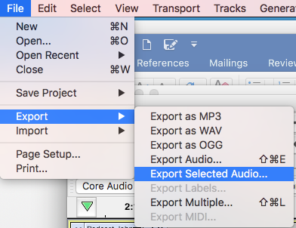
Figure 9 Export Selected Audio
- Enter the file name of the new file and select the location where you want the file to be saved.
For the File type make sure you select the “WAV” option. Click Save.
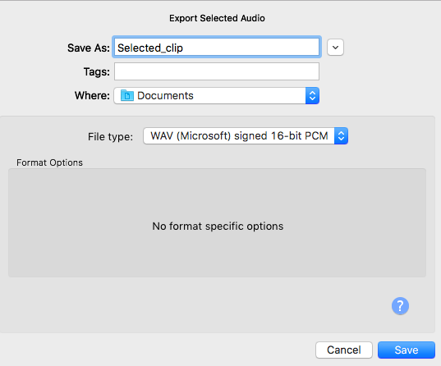
Figure 10 Save Selected Audio
- Edit the meta data for the new file if you wish. Click OK.
Your .wav file should now be saved in the location you selected.

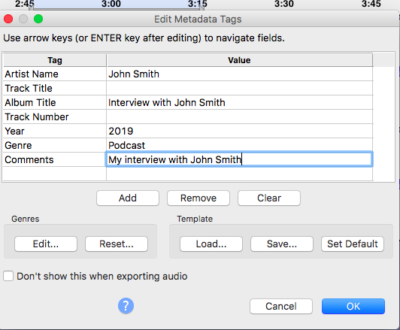
Figure 11 Meta data

