How to Extract Time Codes from your Sound File

- Important: Based on your assignment you will produce a storyboard that represents how your video will unfold. The storyboard is made up of the slides in your video along with what is being said at every slide. Accordingly, you will need to extract corresponding time codes from your project’s sound file.

The tip-sheet “How to Create an Adobe Spark Video” will walk you through the steps of creating Adobe Spark slides that correspond to the extracted time codes. Note that in Adobe Spark slides cannot extend for more than 30 seconds.

- Open the Audacity application on your computer.
Figure 1 Audacity Logo
- Select File->Open. Navigate to the .wav file that contains your full recording and open it.

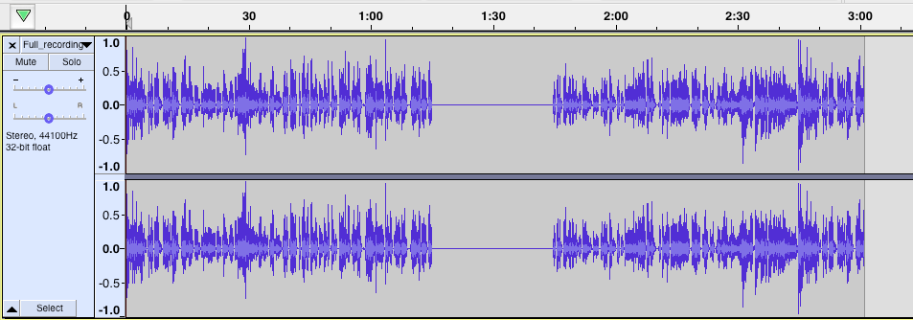
Figure 2 Sound File in Audacity
Note: You can use the zoom buttons to get a more/less detailed view of your tracks.

Figure 3 Zoom Buttons

- At the bottom of the Audacity window you find the selection tool bar. The Audio Position shows the current audio position while playing or recording. Click the Audio Position drop down and select “seconds” to display the time in seconds.
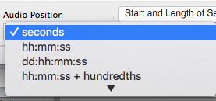
Figure 4 Show Audio Position in Seconds
- At the beginning of your recording the Audio Position will be at 0 seconds.

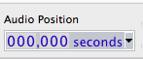
Figure 5 Audio Position at 0 seconds

- Click Play to start listening to the recording. Click Pause to stop the recording at the exact time where you need to transition to your second slide.

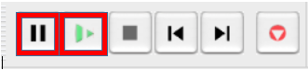
Figure 6 Play and Pause Buttons
- Note down the Audio Position at the time you pause the recording. The image below shows the audio paused at 10 seconds. This will the duration of the first slide in your video recording.

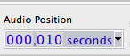
Figure 7 Audio Position at 10 seconds
- Place the Audacity marker at the position where the first slide ends and the second slide starts (in this example at 10 seconds).
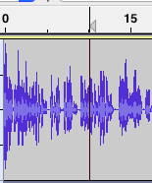
Figure 8 Audacity Marker at 10 seconds
- Click Play to start listening to the recording at 10 seconds. Click Pause to stop the recording at the exact time where you need to transition to your third slide. Note down the Audio Position at the time you pause the recording. In this example it is 21 seconds.

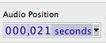
Figure 9 Audio Position at 21 seconds
Your second slide should start at 10 seconds and end at 21 second. The duration of the second slide is therefore 11 seconds (21-10). Note this number down.

- Repeat the steps above until you have the time codes for all the slides. At the end you should have noted down the duration of each slide in your story board.

