How to Install Audacity on your Computer

- Go to https://www.audacityteam.org/download/

- You will find links to download Audacity for Windows and Mac OS. Click on the appropriate link to go to the “Recommended Download” page.

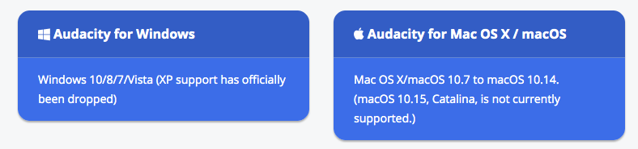
Figure 1 Audacity Download Links

- Scroll to find the system and machine requirements required to download the latest Audacity version. Verify that your computer is running an operating system supported by Audacity and has the minimum RAM/Processor speed.

- Follow the instructions in the download page to download Audacity to your computer. The instructions will take you to the Fosshub website where the downloads are located. Select Windows Installer if your computer is Windows, or macOS DMG if you are on a Mac.

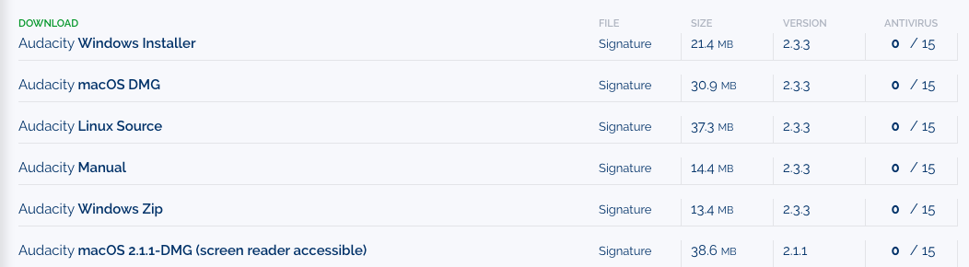
Figure 2 Download Links on Fosshub

