How to Record your Voice in Audacity

- Important: It is best to create a folder on your desktop to store your original interview and all other audio and project files.

- Open the Audacity application on your computer.
Figure 1 Audacity Logo
- Click Tracks->Add New->Mono Track to add a new track to your Audacity Project

Figure 2 Add New Mono Track
An empty audio track will appear in the Audacity window.

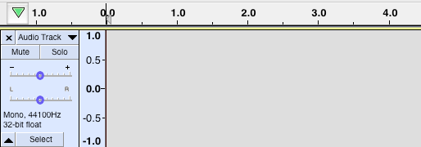
Figure 3 Empty Audio Track
- Click on the Audio Track label and select “Name..”. Rename the track to “My narration” – or any other meaningful name.

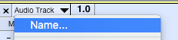
Figure 4 Rename Track

- Select the microphone you want to record your voice from. Also make sure that the Mono Recording Channel is selected.

Figure 5 Microphone Settings
- Click the Record button to start recording your narration. Click the Stop button when you are done to stop the recording.

Figure 6 Recording Buttons
- Once you are done, the Audacity track will look something like this.

Figure 7 Audacity Track
Click Play to listen to your full recording.

- Click File->Export->Export Selected Audio.

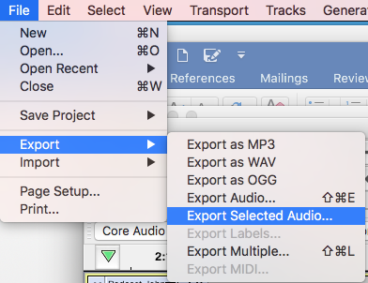
Figure 8 Export Selected Audio
- Enter the file name of the new file and select the location where you want the file to be saved.
For the File type make sure you select the “WAV” option. Click Save.
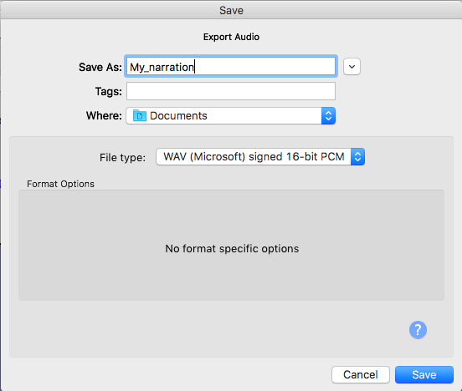
Figure 9 Save Audio File

- Edit the meta data for the new file if you wish. Click OK.
Your .wav file should now be saved in the location you selected.

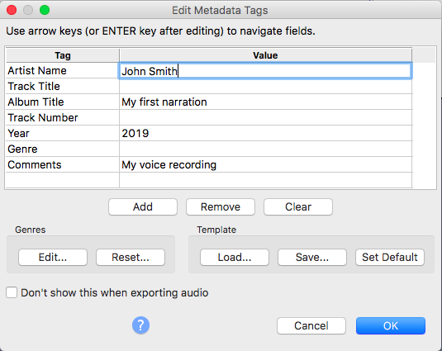
Figure 10 Meta data

